(Approx. 466 words)

Ubuntu 18.04 LTS
by Cal Esneault, Co-Editor, Workshop, SIG leader,
Cajun Clickers Computer Club, LA
June 2018 issue, Cajun Clickers Computer News
www.clickers.org
tsa70785 (at) gmail.com


Canonical just released Ubuntu 18.04 LTS, "Bionic Beaver," with long-term support (LTS) for 5 years. Development releases (issued every 6 months ) are not recommended due to a short 9-month support period. If you are running Ubuntu 17.10, you should be able to do an “in-place” upgrade, but if you are running the last LTS version (16.04), Canonical recommends you wait for the first update (18.04.1). For a quick test, I tried a live USB version.

In 2017, Canonical switched its strategy to concentrate on items of more commercial value (Cloud, Internet of Things). It dropped the “Unity 7" desktop and switched to GNOME to reduce its own support resources. The new LTS continues with GNOME 3.2 8 (shown below). An interim test of the Wayland display manager was made last year, but this LTS version uses the traditional Xorg manager for stability with legacy software (although future plans suggest Wayland will eventually be used for the next LTS).

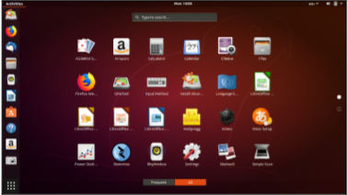

The main panel with “favorites” can be placed vertically or horizontally, and the launcher activates a selection screen of icons for installed software. Typical for consumer distros, Ubuntu 18.04 has a lot of pre-installed software. New this year is a “minimal” version which ships with only essential items so that expert users can configure their system as desired for maximum efficiency

This new LTS has the GNOME “Activities” approach for displaying virtual desktops (see below). Also, Canonical has finally moved the maximize/minimize buttons back to the right-hand side (like just about everyone else).
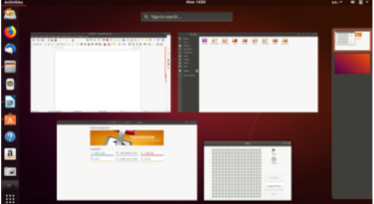

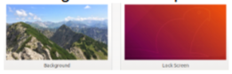
One reason to switch to the new LTS version is refresh of popular software in the default repository. For example, LibreOffice 6.0, Thunderbird 52, Nautilus 3.26, and others are now standard. In addition, you will also find support for Thunderbolt 3, color emoji, and Snap apps. Addition al software is readily available using the GNOME software resource. A new set of images was developed for use for the lock screen and background. There has been some concern with the start of Canonical tracking some connection information (version used, CPU type, etc.).

Ubuntu 18.04 LTS uses the new Linux Kernel 4.15 which improves security against malware and also adds new hardware drivers. Other technical improvements include special versions for use of Ubuntu on “cloud” services (such as Amazon AWS and MS Azure). Early reviews indicate that 18.04 is a very solid release that focuses on getting things right and is worthy of being installed as a long-term system for production use.

Concurrent with the Ubuntu release, the other Ubuntu “flavors” are also being updated (Kubuntu, Xubuntu, Lubuntu, etc.). This year, Ubuntu Budgie has been officially added to the mix.

